Value based operating room triage during COVID-19

Benjamin Gravesteijn*, Eline Krijkamp*, Jan van Busschbach, Jan van Saase, Ernest van Veen, Isabel Retel-Helmrich, Céline van Lint, Sophie Bruinsma, Hester Lingsma/Rob Baatenburg de Jong

Intention to be submitted to: NEJM

# Abstract

## Background

A substantial amount of the non-urgent surgeries were deferred due to the COVID-19 crisis. The current strategy to prioritize this delay is primarily based on expert opinion, which is inconsistent and does not likely benefit the population as a whole. Our aim was to develop an objective measure of urgency for semi-elective surgery, based on the principles on value based health care.

## Methods

A three-state Markov decision model was developed, based on a preoperative state, a postoperative state, and a dead state. For the survival parameters as input for the model, we used Dutch registry data and data (treatment effect estimates, survival data) from the literature. For the quality of life model input parameters, we used the disutility weights of the burden of disease study by the WHO. Missing data on quality of life of health states were imputed by an expert panel. Finally, we used data from the literature as input for time to no effect on survival or quality of life, and average age. We performed a probabilistic sensitivity analysis with 100 iterations. We investigated the strategies of delaying surgery from two weeks up to a year (with intervals of 10 weeks) and no surgery at all.

## Results

The 35 most commonly performed procedures in our hospital were included (44% of the total semi-elective programme). The maximum Quality Adjusted Life Years (QALYs) expected per procedure ranged from 0.02 to 10.3 The 3 most urgent interventions were repairing an atrial septum defect (-0.022 QALY/week, 95% CI: -0.028 – -0.018), renal transplant (-0.021 QALY/week, 95% CI: -0.025 – -0.018), surgically repairing an abdominal aneurysm of the aorta (-0.021 QALY/week, 95% CI: -0.023 – -0.018). The 3 least urgent interventions were resection of high-grade glioma (-0.0041 QALY/week, 95% CI: -0.0044 – -0.0037), resection of severe head- or neck carcinoma (-0.0047 QALY/week, 95% CI: 0.0045 – 0.0037), resection of severe salivary gland carcinoma (-0.0058 QALY/week, 95% CI: 0.0070- 0.0047).

## Conclusion

The most commonly performed semi-elective surgical procedures in our hospital varied widely in urgency in terms of QALY loss per week. Moreover, some commonly performed procedures were not associated with a large potential gain in QALYs. These results have direct implications for current prioritization of surgical care during the COVID-19 crisis and beyond. A broader range of procedures should however be considered for widespread application.

## 

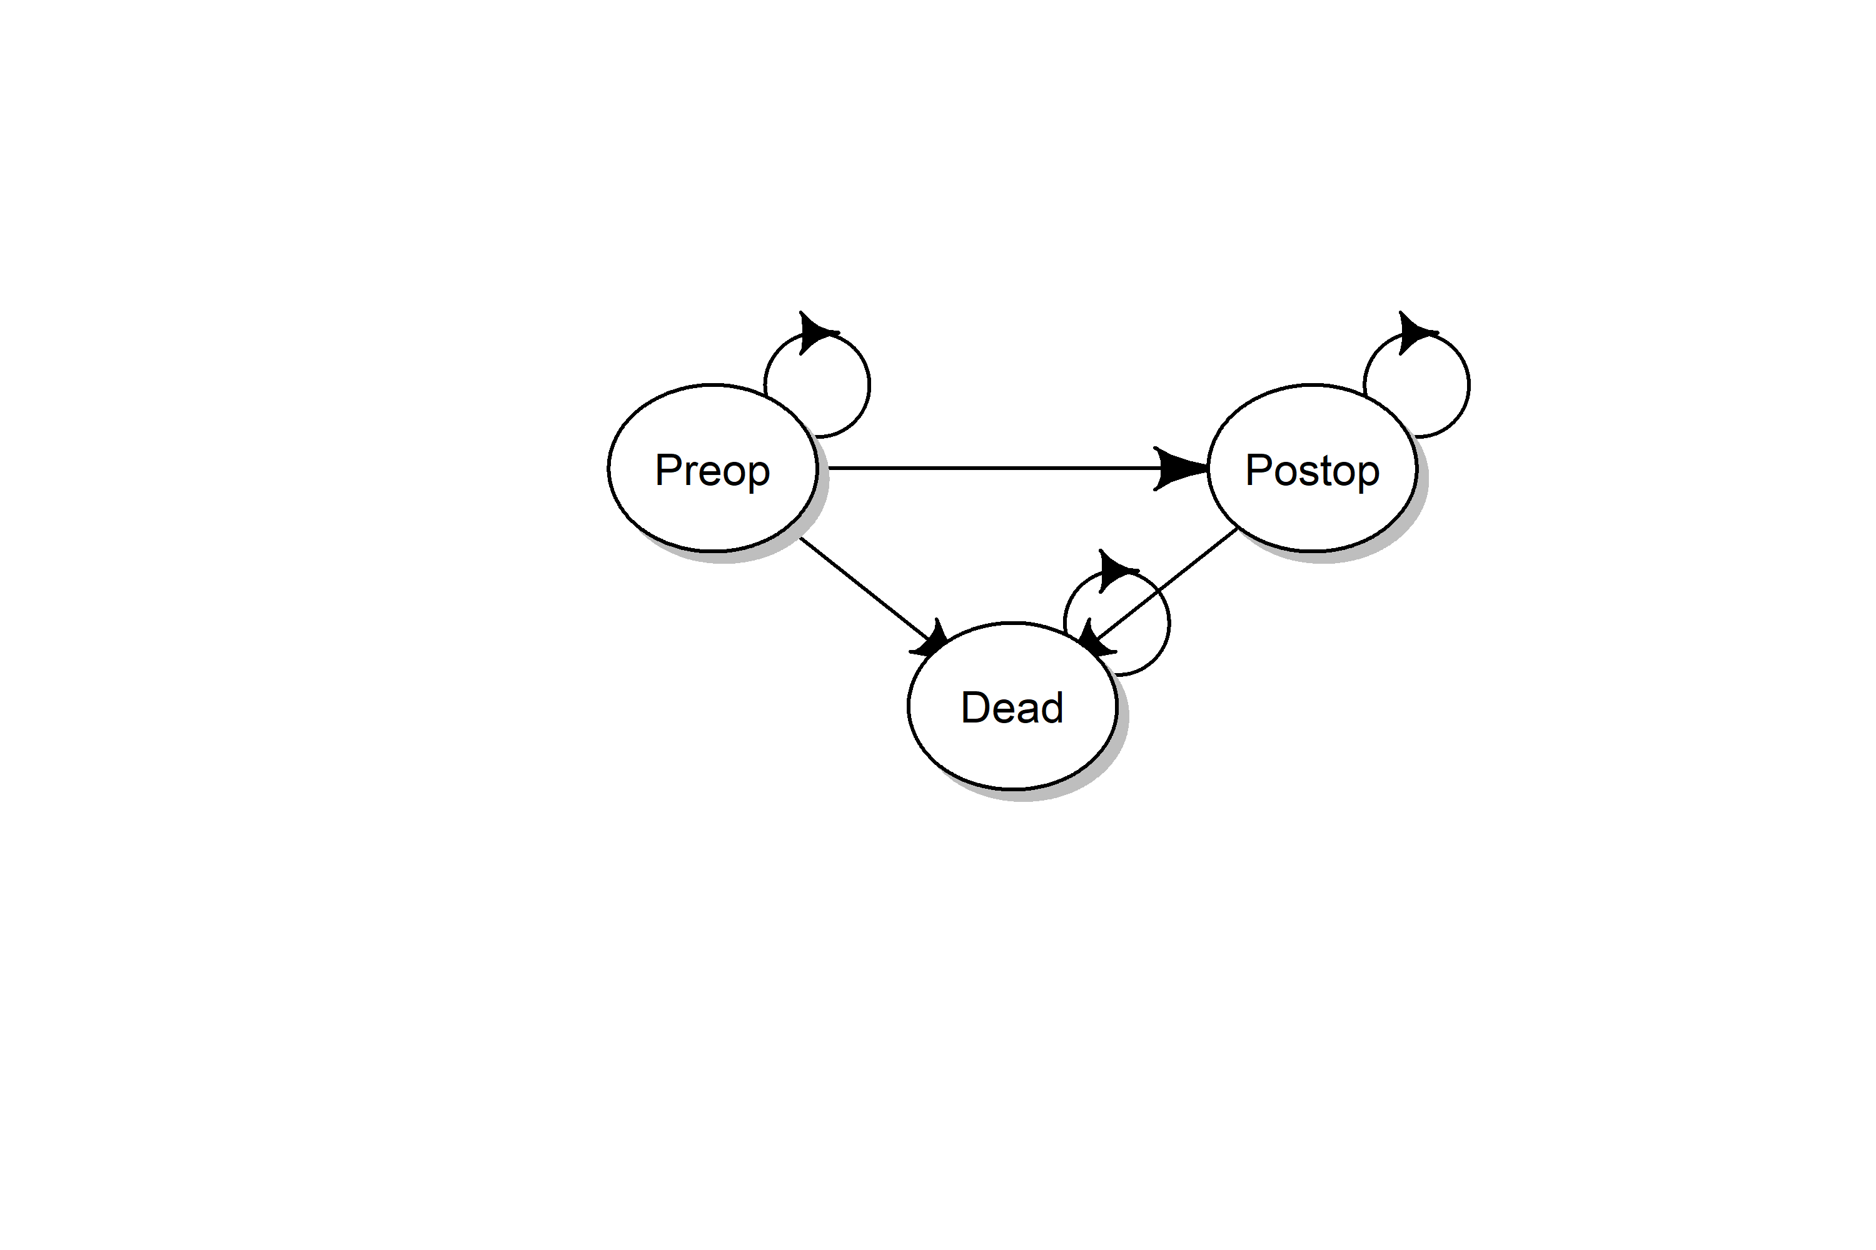

Figure 1, structure of the decision model. The model is a Markov model consisting of three states: a preoperative state (Preop), a postoperative state (Postop), and a the absorbing state Dead.

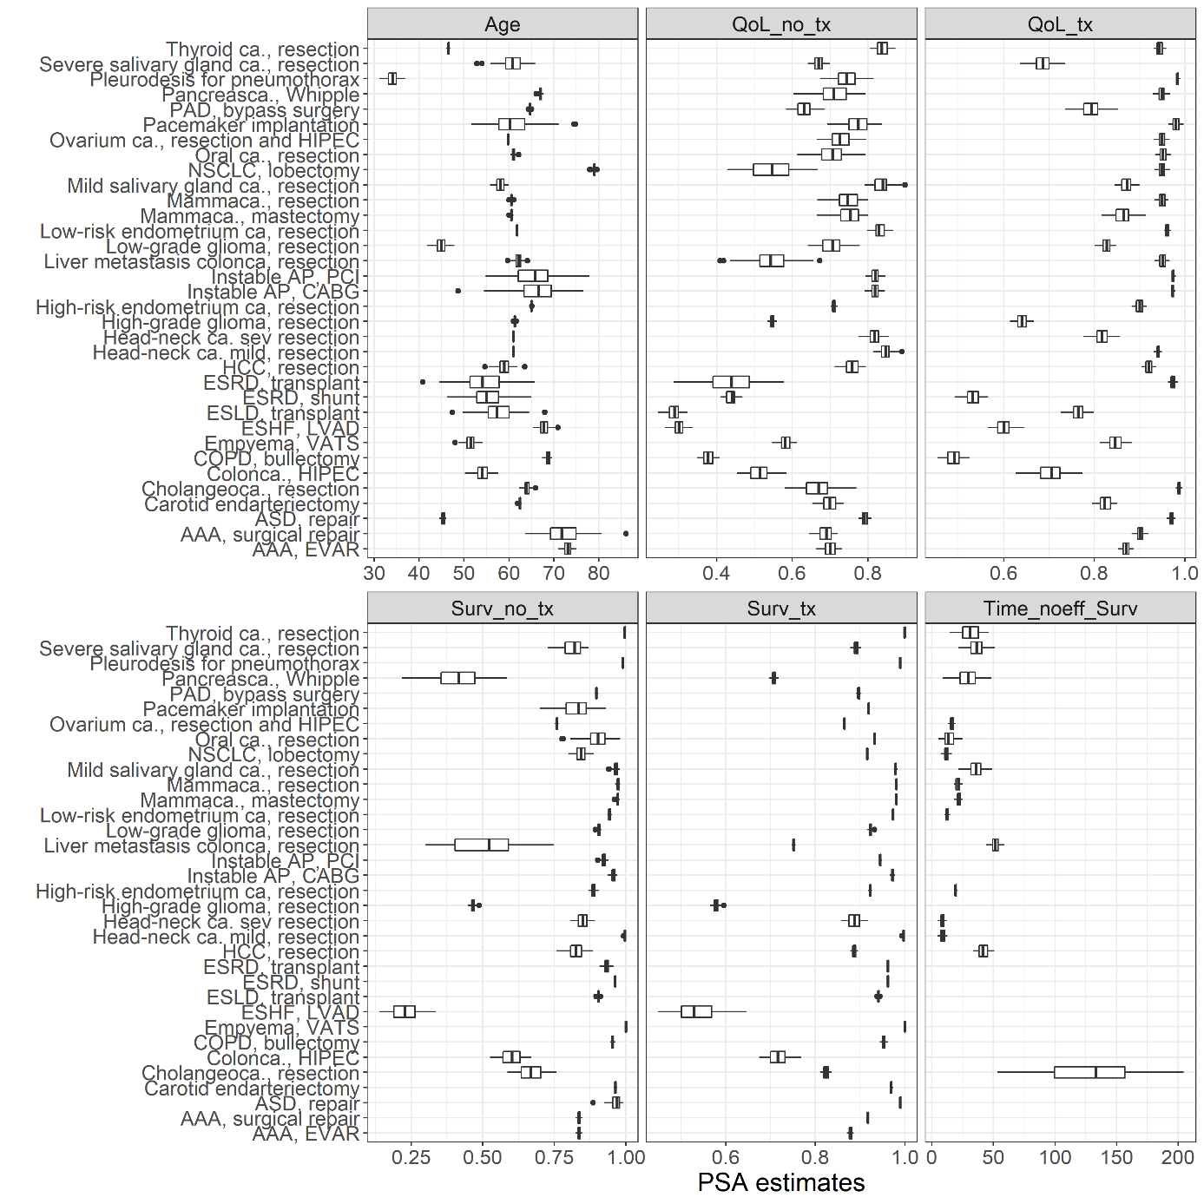

Figure 2, input parameters for the model. For a full list of input parameters per disease and source, see appendix A. Qol_no_tx: Quality of Life without treatment; QoL_tx: quality of life with treatment; Surv_no_tx: 1-year survival probability without treatment; Surv_tx: 1-year survival probability with treatment; Time_noeff_surv: days until no treatment is effective. ESRD: end-stage renal disease; ASD: atrial septum defect; VATS: video assisted thoracoscopic surgery; ESLD: end-stage liver disease; AAA: aneurysm of the abdominal aorta; AP: angina pectoris; CABG: coronary artery bypass graft; PCI: percutaneous coronary intervention; NSCLC: non-small cell lung carcinoma; EVAR: endovascular aortic repair; ca.: carcinoma; PAD: peripheral arterial disease; HCC: hepatocellular carcinoma; ESHF: end-stage heart failure; HIPEC: hyperthermic intraperitoneal chemotherapy.

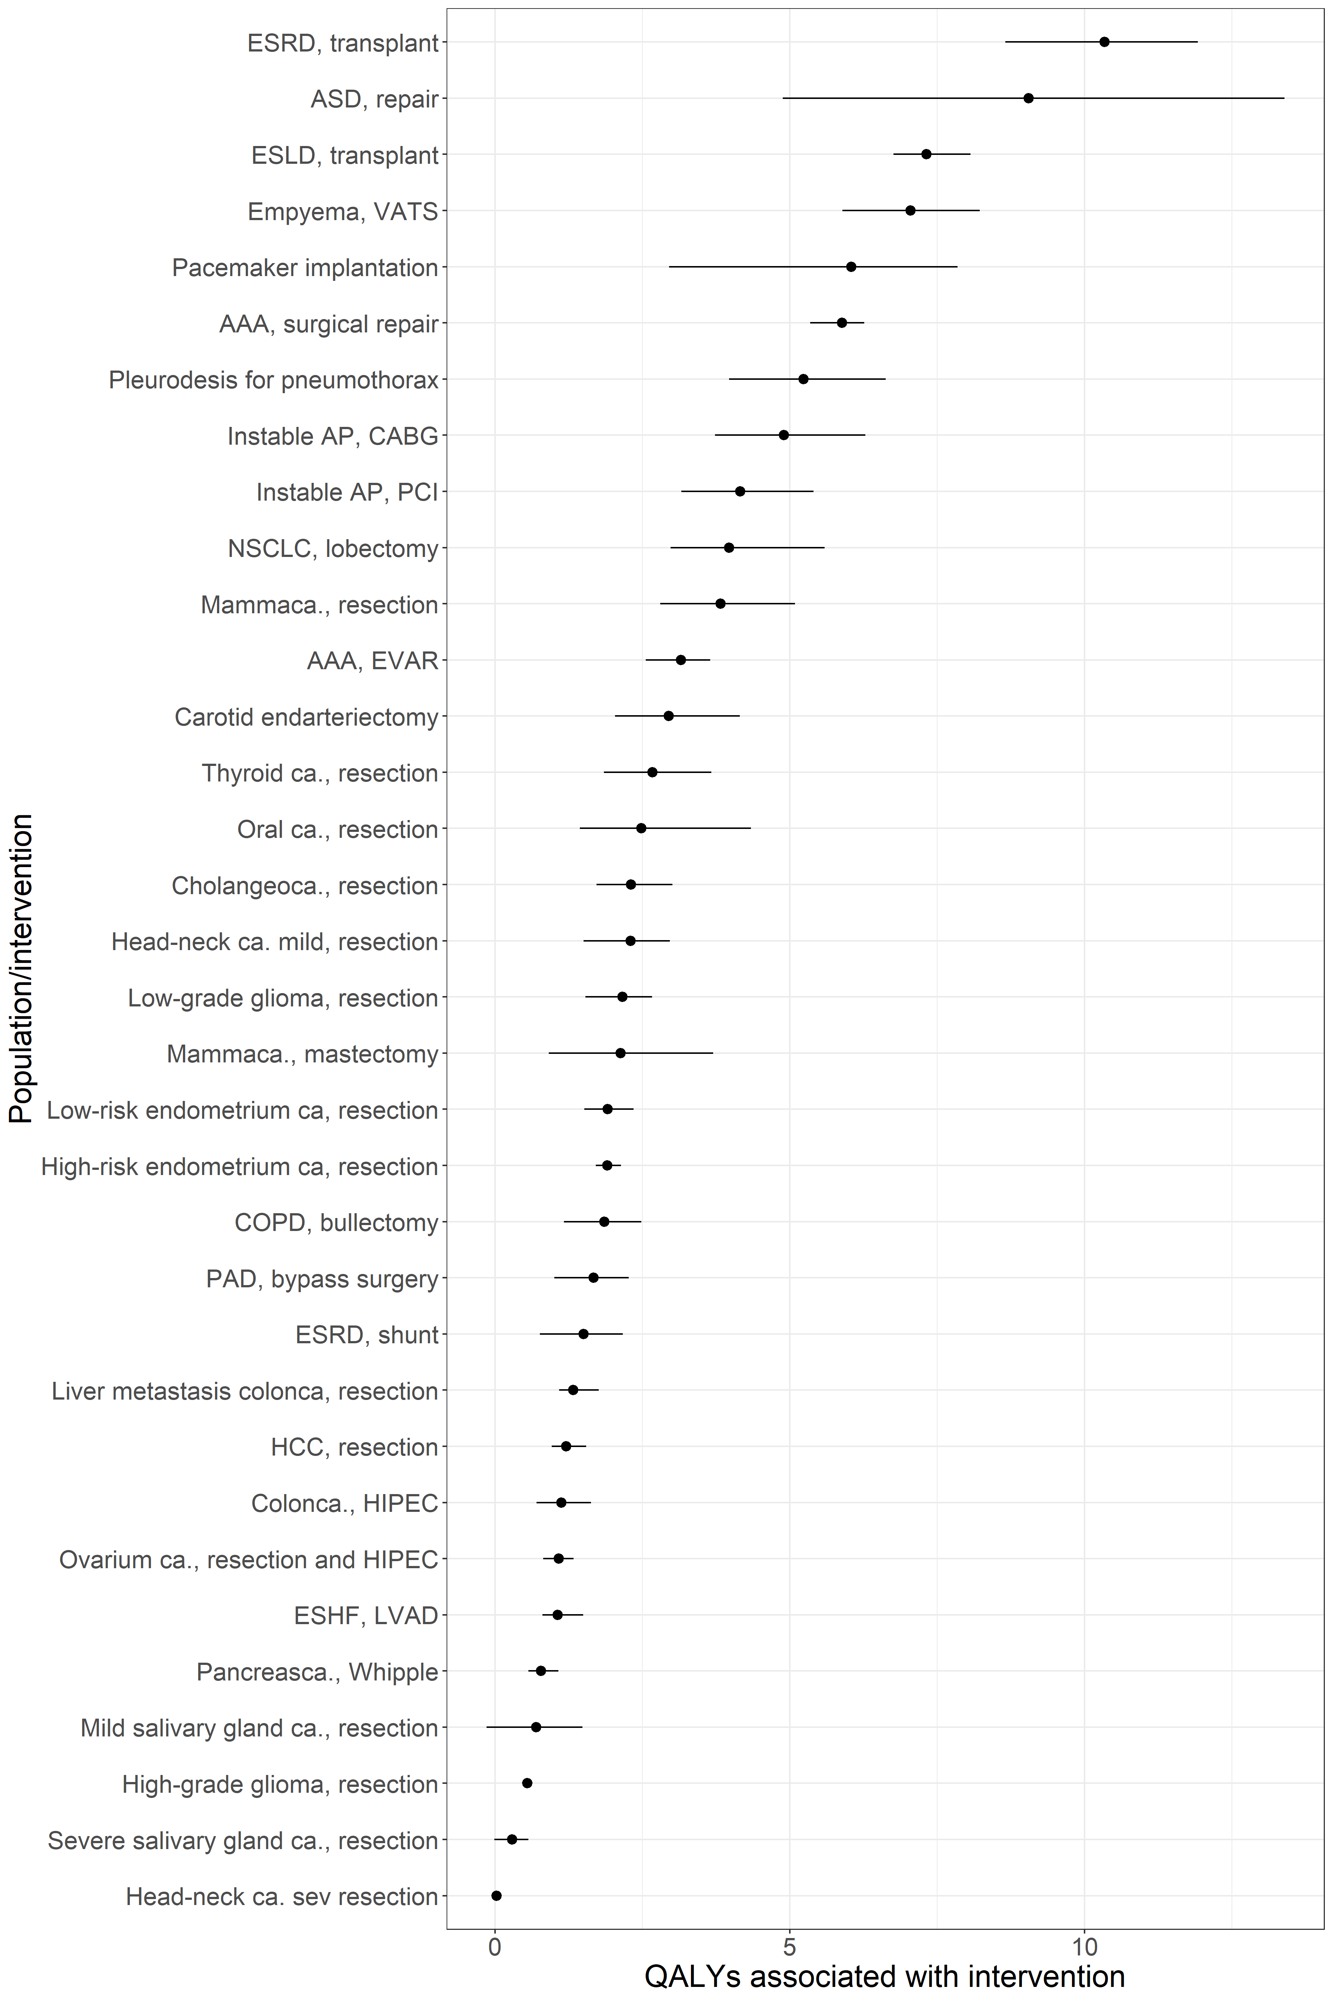

Figure 3, the maximum expected QALYs per intervention, in descending order. The estimates and 95% confidence intervals are shown. The model output for no surgery was subtracted from the model output for a delay of 2 weeks. The actual data are presented in appendix B. ESRD: end-stage renal disease; ASD: atrial septum defect; VATS: video assisted thoracoscopic surgery; ESLD: end-stage liver disease; AAA: aneurysm of the abdominal aorta; AP: angina pectoris; CABG: coronary artery bypass graft; PCI: percutaneous coronary intervention; NSCLC: non-small cell lung carcinoma; EVAR: endovascular aortic repair; ca.: carcinoma; PAD: peripheral arterial disease; HCC: hepatocellular carcinoma; ESHF: end-stage heart failure; HIPEC: hyperthermic intraperitoneal chemotherapy.

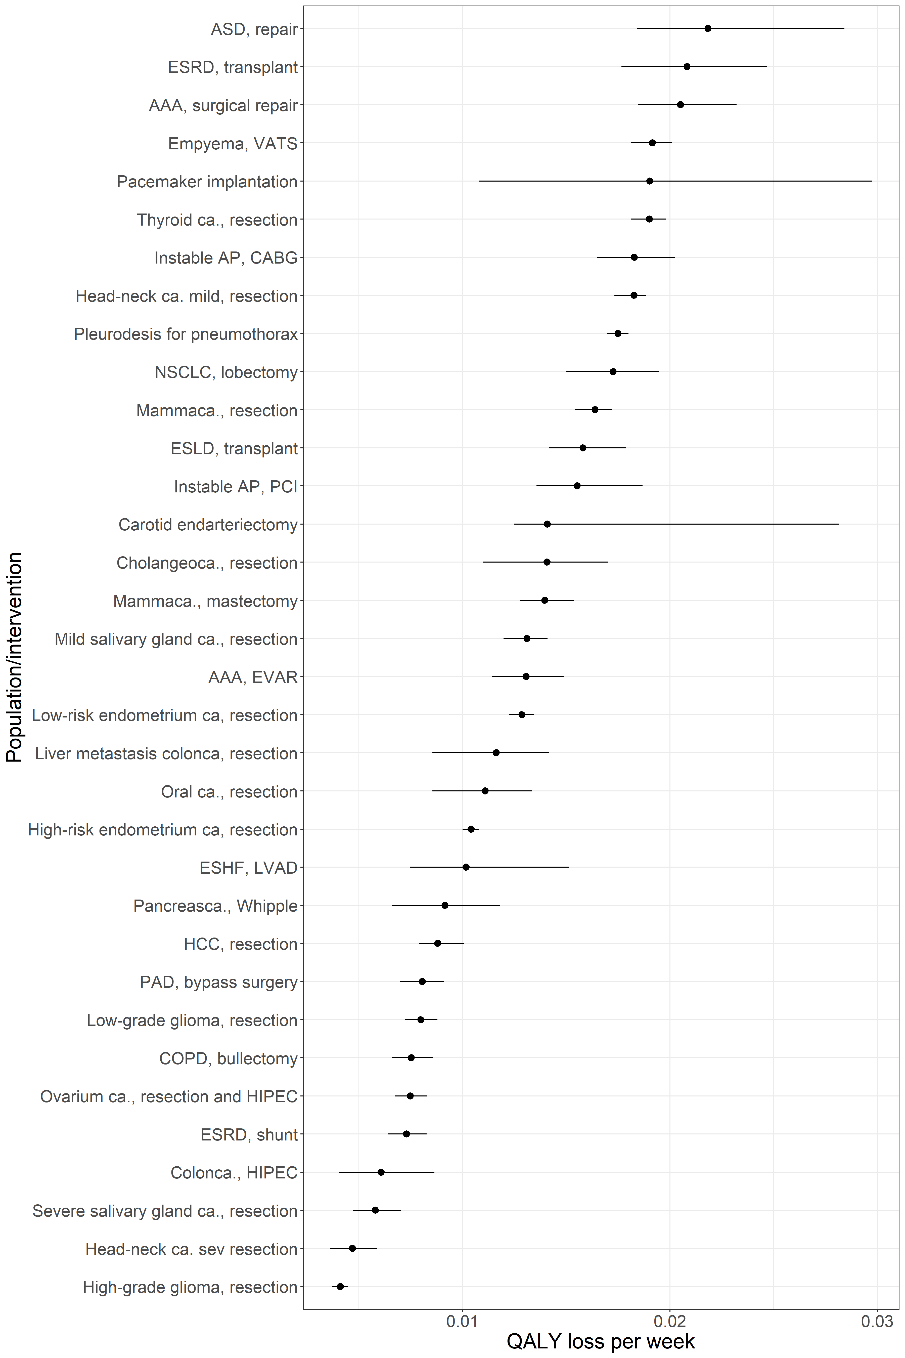

Figure 4, the loss of QALYs per week of delay for the investigated interventions. The estimates and 95% confidence intervals are shown. The actual data are presented in appendix B. ESRD: end-stage renal disease; ASD: atrial septum defect; VATS: video assisted thoracoscopic surgery; ESLD: end-stage liver disease; AAA: aneurysm of the abdominal aorta; AP: angina pectoris; CABG: coronary artery bypass graft; PCI: percutaneous coronary intervention; NSCLC: non-small cell lung carcinoma; EVAR: endovascular aortic repair; ca.: carcinoma; PAD: peripheral arterial disease; HCC: hepatocellular carcinoma; ESHF: end-stage heart failure; HIPEC: hyperthermic intraperitoneal chemotherapy.

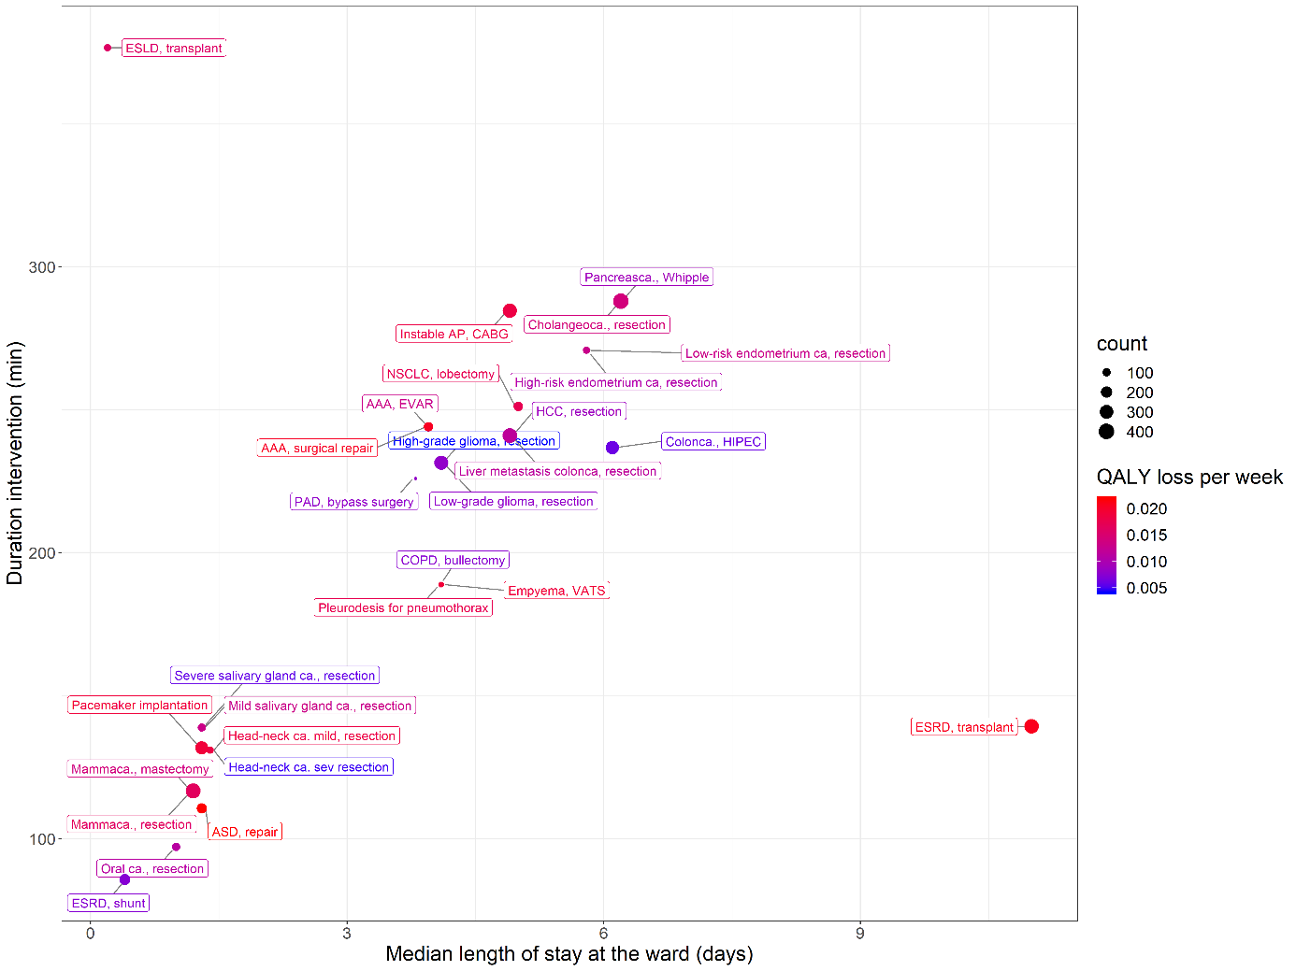

Figure 5, showing the mean duration of the intervention, the mean length of stay, and the frequency that interventions are performed in our hospital. The color coding represents their urgency in terms of QALY loss per week. The length of stay in days on the X-axis is the median length of stay within the hospital. This include both intensive care and non-intensive care stay. In Table 1, the length of stay is also showed separately for the ICU stay and non-ICU stay. ESRD: end-stage renal disease; ASD: atrial septum defect; VATS: video assisted thoracoscopic surgery; ESLD: end-stage liver disease; AAA: aneurysm of the abdominal aorta; AP: angina pectoris; CABG: coronary artery bypass graft; PCI: percutaneous coronary intervention; NSCLC: non-small cell lung carcinoma; EVAR: endovascular aortic repair; ca.: carcinoma; PAD: peripheral arterial disease; HCC: hepatocellular carcinoma; ESHF: end-stage heart failure; HIPEC: hyperthermic intraperitoneal chemotherapy.

Table 1, capacity requirements of the studied interventions in our hospital, in descending order of urgency.

|  |  |  |  |  |
| --- | --- | --- | --- | --- |
| Intervention (in descending order of urgency) | N performed since 2018 | Duration of intervention, min (IQR) | Length of stay – non-ICU, median (IQR) | Urgency, QALY loss/week (95% CI) |
| ASD, repair | 164 | 111 | 1.3 (0.6 - 1.9) | 0.022 (0.018 - 0.028) |
| ESRD, transplant | 346 | 139 | 11 (7.5 - 12.3) | 0.021 (0.018 - 0.025) |
| AAA, surgical repair | 138 | 244 | 3.95 (2.35 - 6.6) | 0.021 (0.018 - 0.023) |
| Empyema, VATS | 55 | 189 | 4.1 (3.1 - 7.2) | 0.019 (0.018 - 0.020) |
| Pacemaker implantation | 273 | 132 | 1.3 (1.1 - 2.1) | 0.019 (0.011 - 0.030) |
| Instable AP, CABG | 336 | 285 | 4.9 (3.8 - 6.4) | 0.018 (0.016 - 0.020) |
| Head-neck ca. mild, resection | 80 | 131 | 1.4 (1 - 4.1) | 0.018 (0.017 - 0.019) |
| Pleurodesis for pneumothorax | 55 | 189 | 4.1 (3.1 - 7.2) | 0.017 (0.017 - 0.018) |
| NSCLC, lobectomy | 133 | 251 | 5 (3.9 - 7.9) | 0.017 (0.015 - 0.019) |
| Mammaca., resection | 383 | 117 | 1.2 (0.4 - 2.1) | 0.016 (0.015 - 0.017) |
| ESLD, transplant | 81 | 376 | 0.2 (0.2 - 5) | 0.016 (0.014 - 0.018) |
| Cholangeoca., resection | 413 | 288 | 6.2 (0.5 - 13) | 0.014 (0.011 - 0.017) |
| Mammaca., mastectomy | 383 | 117 | 1.2 (0.4 - 2.1) | 0.014 (0.013 - 0.015) |
| Mild salivary gland ca., resection | 100 | 139 | 1.3 (1 - 3.3) | 0.013 (0.012 - 0.014) |
| AAA, EVAR | 138 | 244 | 3.95 (2.35 - 6.6) | 0.013 (0.011 - 0.015) |
| Low-risk endometrium ca, resection | 83 | 271 | 5.8 (2.9 - 6.9) | 0.013 (0.012 - 0.013) |
| Liver metastasis colonca, resection | 355 | 241 | 4.9 (1.6 - 7.6) | 0.012 (0.009 - 0.014) |
| Oral ca., resection | 103 | 97 | 1 (0.3 - 2.3) | 0.011 (0.009 - 0.013) |
| High-risk endometrium ca, resection | 83 | 271 | 5.8 (2.9 - 6.9) | 0.010 (0.010 - 0.011) |
| Pancreasca., Whipple | 413 | 288 | 6.2 (0.5 - 13) | 0.009 (0.007 - 0.012) |
| HCC, resection | 355 | 241 | 4.9 (1.6 - 7.6) | 0.009 (0.008 - 0.010) |
| PAD, bypass surgery | 43 | 226 | 3.8 (2.8 - 5) | 0.008 (0.007 - 0.009) |
| Low-grade glioma, resection | 329 | 231 | 4.1 (3.1 - 5.3) | 0.008 (0.007 - 0.009) |
| COPD, bullectomy | 55 | 189 | 4.1 (3.1 - 7.2) | 0.008 (0.007 - 0.009) |
| ESRD, shunt | 190 | 86 | 0.4 (0.3 - 1.3) | 0.007 (0.006 - 0.008) |
| Colonca., HIPEC | 283 | 237 | 6.1 (0.3 - 11.3) | 0.006 (0.004 - 0.009) |
| Severe salivary gland ca., resection | 100 | 139 | 1.3 (1 - 3.3) | 0.006 (0.005 - 0.007) |
| Head-neck ca. sev resection | 80 | 131 | 1.4 (1 - 4.1) | 0.005 (0.004 - 0.006) |
| High-grade glioma, resection | 329 | 231 | 4.1 (3.1 - 5.3) | 0.004 (0.004 - 0.004) |

## Appendix A

An overview per disease of the distribution and source of the input parameters and a graphical representation of the output of the model.

## Appendix B

A summary of the estimates of the decision model for the QALYs associated with each intervention for each strategy and the loss of QALYs per week delay.